**1) Why a Business Intelligence Program, Business Intelligence and Program Success**

**Ans:**

Business intelligence (BI) is software that ingests business data and presents it in user-friendly views such as reports, dashboards, charts and graphs. BI tools enable business users to access different types of data — historical and current, third-party and in-house, as well as semi-structured data and unstructured data like social media. Users can analyze this information to gain insights into how the business is performing.

Business intelligence is the process of surfacing and analyzing data in an organization to make informed business decisions. BI covers a broad spectrum of technologies and methods, from the way that data is organized and analyzed, all the way to how findings are reported. BI is used to answer how a business performed in the past and why those outcomes came about.

Execution of a successful business intelligence strategy requires a strong organization of how data is used from start to finish:

* **Data collection**: A business needs to understand where they can collect data from visitors and customers, and how they can be organized into a form that can be analyzed.
* **Data storage**: Data relevant to businesses are numerous and often large in scope. In order to be useful, that data must be stored in a place that data stakeholders can reliably access, such as in a SQL database. A storage solution should always be up-to-date so that a company can act on changes in data quickly.
* **Data analysis**: The core of business intelligence is focused on descriptive and diagnostic analytics, which answers questions of where your company has been, where it is now, and why things are the way they are now. BI tools need to be able to draw from data storage to conduct these different types of analyses.
* **Data reporting**: All of our data and analyses will do no good if they do not reach decision makers and other stakeholders. BI should convey data and insights in ways that people with fewer contexts can still quickly understand and use them to make decisions.

The overall objective of business intelligence is to allow a business to make informed decisions. A company with a working BI strategy will have data that is accurate, complete, and organized. Business intelligence can be used to show historic patterns to help stakeholders gauge the health of their organization, alerting them to problems as well as potential improvements.

Business intelligence can also help organize teams, keeping them aware of key performance indicators (KPIs). Awareness of KPIs through dashboards and reports keeps teams aligned and focused on their goals. Easy access to metrics and KPIs also frees up time and energy to execute on the tasks that will impact the company’s performance.

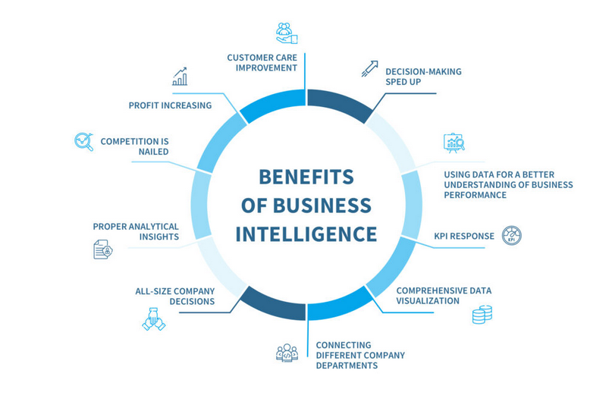

Leveraging BI solutions for business growth will inevitably turn out to be a brilliant idea once a company starts receiving higher income and higher retention rates. Struggling with setting up a BI campaign just right to reach business goals will get easier with taking these steps:

* **Getting to know the business intelligence system.** When starting dealing with any BI system it is necessary to take time and learn what this system can actually do in terms of planning, executing, and analyzing the data.
* **Working with the data.** Before submitting tons of data to the BI system, it is necessary to learn the data’s features and peculiarities, where it is taken from, and what benefits can this data analysis bring to the decision-making processes.
* **Prioritizing the BI reports.** Some business intelligence reports can simply not work for a particular business or particular goal-reaching. To get the most out of the data analysis, it is important to determine the goals of the analysis itself.
* **Sharing access to information with the employees.** All employees, involved in some way or another in data analysis, should have access to all the data needed for business intelligence projects.

**Architecture:**

The BI architecture defines the framework in which all the technologies for BI are implemented in a business. This includes IT systems and BI tools. The BI architecture is crucial in implementing a successful BI program that can use data analysis and reporting to help a business track performances, optimize processes, identify new opportunities, improve planning, and make better decisions.

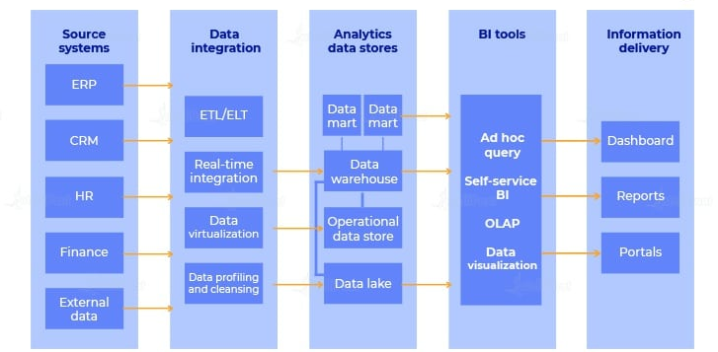

**2) The Analytics Spectrum and Taming the Information Explosion:**

**Ans:**

**The Analytics Spectrum:**

Discover insights, predict possibilities, and present findings to your business and customers.

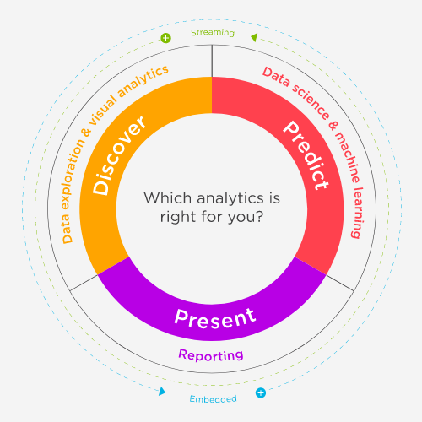

The concepts of ‘‘business intelligence’’ and ‘‘analytics’’ include tools and techniques supporting a collection of user communities across an organization, as a result of collecting and organizing multiple data sources to support management and decision making at operational, tactical, and strategic levels.

Through the capabilities of a BI discipline, actionable intelligence can be delivered to best serve a wide range of target users. Organizations that have matured their data warehousing programs allow those users to extract actionable knowledge from the corporate information asset and rapidly realize business value.

But while traditional reporting engines and data warehouse infrastructures support business analyst querying and canned reporting or senior management dashboards, a comprehensive program for information insight and intelligence can enhance decision-making processes for all types of staff members in numerous strategic, tactical, and operational roles. Even better, integrating the relevant information within the immediate operational context becomes the differentiating factor.

On the one hand, customer analysis that reports general sales results provides some measurable value. On the other hand, real-time actionable intelligence can provide specific alternatives to a sales person talking to a specific customer based on that customer’s interaction history in ways that best serve the customer while simultaneously optimizing corporate profitability as well as the salesperson’s commission.

Maximizing overall benefit to all participants and stakeholders will lead to business process optimization improvements in sales, increased customer satisfaction and employee satisfaction, improved response rates, reduced overhead costs, and so on. There are many different types of analytical capabilities provided by BI,and all help suggest answers to a series of increasingly valuable questions.

These questions are both increasingly complex and add greater cumulative value. Here are the questions in increasing order of complexity:

* **What?** Predefined reports will provide the answer to the operational managers, detailing what has happened within the organization and various ways of slicing and dicing the results of those queries to understand basic characteristics of business activity (e.g., counts, sums, frequencies, locations, etc.). Traditional BI reporting provides 20/20 hindsight it tells you what has happened, it may provide aggregate data about what has happened, and it may even direct individuals with specific actions in reaction to what has happened.
* **Why?** More comprehensive ad hoc querying coupled with review of measure-ments and metrics within a time series enables more focused review. Drilling down through reported dimensions lets the business client get answers to more pointed questions, such as the sources of any reported issues, or comparing specific performance across relevant dimensions.
* **What if?** More advanced statistical analysis, data mining models, and forecasting models allow business analysts to consider how different actions and decisions might have impacted the results, enabling new ideas for improving the business.
* **What next?** By evaluating the different options within forecasting, planning, and predictive models, senior strategists can weigh the possibilities and make strategic decisions.
* **How?** By considering approaches to organizational performance optimization,the senior managers can adapt business strategies that change the way the organization does business.

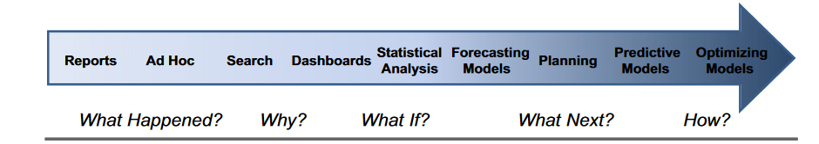

**Taming the Information Explosion :**

The information explosion is the **rapid increase in the amount of published information or data and the effects of this abundance**. As the amount of available data grows, the problem of managing the information becomes more difficult, which can lead to information overload.

1)Business intelligence enables the user to take effective decisions and help in providing accurate reports by retrieving information from the main data source. Big data 's main purpose is to record data, operate data, analyze data for both structured and unstructured to enhance customer output.

2)Overall, the role of business intelligence is to improve an organization's business operations through the use of relevant data. Companies that effectively employ BI tools and techniques can translate their collected data into valuable insights about their business processes and strategies.

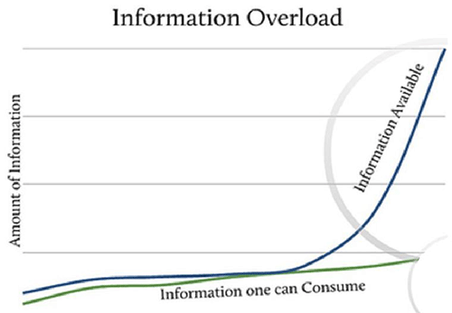

**Business Intelligence Services:**

Business Intelligence (BI) often refers to the traditional set of technology-driven software tools that primarily aim at providing accurate reports and insights into the business and market to its stakeholders. With the ability and function of analyzing raw data into meaningful information, it is simply a set of processes and architectures that help in designing profit strategies for businesses. Except for the manual maintenance of the application, the system is highly automated. It simply extracts data from the one that is mined, slices the data according to the analyzer's preference, and finally presents itself in forms of reports, graphs, etc.

In short, one can say that the service has brought the hardships of business analysts to ease. This is primarily due to its ability to reciprocate the consumer-seller relation through appropriate methods. Although it's a service of older generations, it remains as one of the most sought after methodologies in today’s time and day.

**Business intelligence provides the following benefits :**

* helps in making decisions
* generating quick and precise reports
* feature the standard output
* cost-efficiency
* increases returns
* enhances work procedure

**3) Bridging the Gaps between Information Technology and the Business Users**

**Ans:**

**Page 40-42**

**Bridging the Gaps Between Information Technology and the Business Users ,DICHOTOMY, PARTNERING**

* The evolution of **technical resources** are the success factors in gaining the best advantage from a BI and analytics program is establishing a partnership between the business users and the information technology team

Here what we find lacking between business users and technical team is What are the barriers between these two groups, and how can they be overcome?

To answer this question, we can look at how over time, the evolution of technical resources has had an interesting influence on more than the speed at which things get done

We might call this as a psychological effect on the way people work together based on the allocation and distribution of technical resources.

This can be explained by how technology development evolved and linked to business applications.

* In the early days of computing, all technical people used to shared time on huge computers equipped in large separate rooms; the services provided were purely operational there without BI applications at all.
* But as technology evolved and used for different applications, there are related changes in connecting technology to the business purposes.

And to bridge the gap is by adopting new technologies into business environment and adding more technical support and update them periodically with technical knowledge.

As what we understood till now is for so many organizations today, technology *is* the business. Technology needs to be understood as a critical enabler in every part of the organization from the front line to the back office. It creates new value by crunching data to deliver new insights, it spurs innovation, and it disrupts traditional business models.

The way the information technology department has evolved has imposed an artificial boundary between those who require computer services and those who provide those services. This is mostly because the ability to build user-friendly end-user applications

There is a greater need for both technicians to solve problems with computer use and those who can translate a business user’s problems into a collection of technical issues.

So what has to been done is Senior executives from both technology and business silos are the only ones who can help their companies shift this mindset. These leaders are the ones who most clearly understand the direction in which their organizations are headed and the important role that technology will play along the way.

A key way to **bridge** the **gap between IT and Business** is implementation of a service-centric management approach to IT operations

Think about all of the companies that have been successful with technology. Almost all of them were led by great engineers who later became great businessmen. Think Bill Gates and Steve Jobs. In almost all tech companies today, problems start from an initial separation within the organization. Due to a shortage of tech talent, especially in emerging markets, most companies don’t have the luxury of having someone who speaks both languages. Each group operates differently, which creates a situation of fundamental misunderstanding.

In general what we know is **Business partnering** is the development of successful, long term, strategic relationships between customers and suppliers.

**Business Intelligence programs** are no different.   They, too, require a team effort or partnership to be successful.  That partnership is between the business and the technology functions of a company.

While IT departments are familiar to working with business contacts for application development purposes, the relationship in a **BI program** is different.

And finally we can say that the joint partnership between the business and IT is one of the keys to a successful BI program.  Working via a long term, valued added relationship brings many benefits.

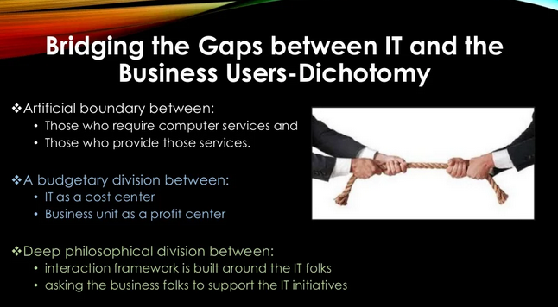

**Knowing the Different Types of Business Intelligence Users:**

**Ans:**

In an enterprise environment there are various ways of how users can interact with data using Power BI. Some users have a need for consuming pre-defined management reports, while other users wish to build their own datasets and create their own analysis.

Types of business users in reporting and analytics: the report consumer, report analyst, self-service data analyst, basic data analyst and advanced data analyst.

Every type of user has its own data needs and requires different types of skills.

**Power User:**

Business intelligence users can come from across the organization. We often talk about two types of business users, the casual business intelligence user and the power user. The difference is that a power user has the capability of working with complex data sets, while the casual user will make use of dashboards to analyze predefined sets of data.

**Business User**

Generally the business user is often a manager, who is looking for ways to help a department operate more efficiently and more effectively. This type of business user is often untrained in using BI tools but is capable of picking up the basics of reporting and can use business intelligence successfully to report on business activities. Often they’ll undergo further training and become fully equipped to perform more in-depth analysis.

**Casual User:**

The casual user is one of the two user groups of the **self service business intelligence**.

Casual users are **executives, managers, field and operations workers, customers and suppliers**. (2) The casual users have a **very basic information needs**. They only want to have a report or dashboard, where they can get the information they need. Additionally sometimes they want to get more details. Then they **change the filters, use the drill down function** or something else with a few clicks. **80% of the time casual users work with delivered reports or dashboards.** The source of the dashboard or report is a **data warehouse** or a **data mart**. It is not necessary that they ask for more information, because the dashboard or report contains all necessary information. But 20% of the time the users need access to the needed information ad-hoc, because the information is not available in the delivered dashboard or report and without that information they can not finish their work. Then they make their own dashboards or reports. (3) But **casual users don’t have the same skills like power users**. They don’t know how they could make a good report or dashboard. So they must learn more about the business intelligence tools, but they don`t want to learn more about that, because they don’t want to spend their time in this kind of work.

Data Aggragator or Data Providers:

Data aggregators will act as an agent to enhance the clients’ data. This is typically done by giving a data set to the data supplier, who then enhances the data and returns it to the client. The aggregator will provide a list of matched records, and then the user can purchase any or all of the matched data instances.

**Operational analytics users:**

who indirectly rely on the results of analytics embedded within operational applications

**Extended enterprise users:**

composed of external parties, customers, regulators, external business analysts, partners, suppliers, or anyone with a need for reported information for tactical decision-making.

**IT User:**

IT is another key player in the BI process. The IT user still plays a central role – maintaining the infrastructure and giving departments the tools that allow them to fulfill their own data requests – however, the role has become more rounded.

These days, IT will cooperate much more closely with departments and the business as a whole. It’s their job to ensure that business users are getting the most from data analytics, and they’re also a key part of data governance and [BI security](https://www.sisense.com/product/govern/). They’ll also bridge the gap between IT and business, helping increase BI adoption across the board.

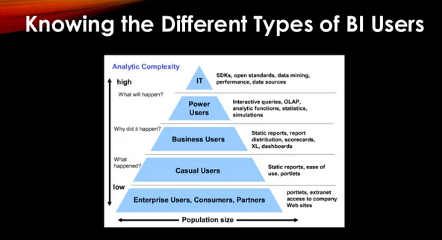

**Developing Your Business Intelligence Roadmap:**

**Ans:**

A good BI roadmap should be aligned closely with business strategy, staying focused on business value with every implementation and performance improvements in multiple facets of the solutions. BI roadmap planning involves three major steps: measuring current state, defining targets and developing an execution plan to achieve targets for each application area.

**Analytic Solutions Roadmap**

Analytic solutions – dashboards, scorecards, reports and ad hoc querying – have to closely align with the needs of the end users. Using a different framework, the BI team should evaluate the current tools, technologies and analytic solutions to see whether they are a fit for various user segments and to develop an analytic solutions roadmap. The analytic solutions roadmap ensures that analytic capabilities are delivered to business in increments based on business priorities.

***Understand the Current State***

A simple matrix, as shown in the following figure, shows a snapshot of what analytic solutions are currently available to a department.

***Plan BI initiatives***

BI teams should strive to provide a full range of analytic capabilities to the business users and consider new analytic capabilities when considering new initiatives for a business area. For example, if a business area has deployed multiple standard reports but no dashboards or scorecards, then new solutions for that business area could be centered on dashboards and scorecards.

**Data Roadmap**

Data requirements for any BI application change constantly; they evolve rapidly based on the inevitable changes in a business environment. Additionally, as analytic tools such as dashboards, scorecards, reports and self-service tools are deployed, it becomes imperative to understand what data elements are available in which tools. A data roadmap helps educate the business users about the complexity of moving the data around via data warehouses and data marts, and then reporting solutions.

***Understand the Current State***

Knowing what data is available for which reporting solution provides the advantage of better visibility for the business users. A simple data roadmap as mentioned below shows data elements currently available in the data warehouse and various reporting solutions.

***Plan Data Availability for Reporting Solutions***

Key data elements in an organization are customer, product, segmentation, sales agents, etc. As the business strategy changes, customer or product segmentation can change, resulting in a need to include that data in the data warehouse and subsequent reporting solutions. Jonathan Geiger shares great insight about various kinds of data changes in his article “Data Warehouse Change Request Management.”  The key categories of data changes are new data in the existing mart, new mart, new data from an existing source, new data from a new source and data not available currently.

The level of effort for data availability in reporting solutions will vary significantly based on the category of the data change required by the business.

Roadmap planning should focus on how to include these new data elements in the various reporting solutions and the data warehouse.

The following figure shows a sample data roadmap.

**Customer Support**

Customer support is a key aspect of how BI solutions are managed and perceived by end users. It is important to develop excellence in customer support to complement well-designed data warehouse and reporting solutions.

***Understand the Current State***

BI should provide visibility to businesses on key metrics related to customer support. Key metrics include number of support tickets logged, tickets resolved within SLAs, and tickets categorized by data, reporting, tool or requirement-related issues

***Develop a High-Level Implementation Plan for Customer Support Improvement***

As a next step, BI teams should identify areas of improvement from the current data and focus on a few areas at a time to ensure meaningful progress is made. Here are some specific strategies to improve customer support.

This also includes

**Deployment and Adoption Roadmap**

**Tools and Technologies (Infrastructure)**

To develop a better partnership with business sponsors, BI teams should educate business teams on the complexity of a technology infrastructure required to run BI solutions.

